**Assignment SAP Leonardo**

Objective: - The objective of the assignment is to create a ML Model and deploy it on Leonardo (BYOM) and serve the model by using an inference app deployed on cloud foundry.

Expectation: - By the end of the assignment you should have the complete understanding of deploying a model and serving it to the rest of the world via a REST client.

Problem statement: - We are going to continue with the same example used in the class for digit classification using TensorFlow.

**Step1**: - Train your model with different classification algorithms

Note: - in the classroom we had used a linear classifier. For the current assignment Implement the model with decision trees

<https://github.wdf.sap.corp/tech-know-school/Machine-Learning/tree/master/modules/6.%20SAP%20Leonardo/slides%20for%20bootcamp/digit%20classifier>

Step 2: - find the performance metrics for your model

1. Accuracy
2. Precision
3. Recall
4. F1 score

Step3: - write the code to save your model as “saved_model” format.

<https://www.tensorflow.org/guide/saved_model>

Step 4: - obtains the service keys for SAP Leonardo from cloud foundry (Skip if you have already created)

Note: - follow the guide to deploy the model on Leonardo

<https://github.wdf.sap.corp/pages/ICN-ML/docs/byom/tutorials/byom-tf-tutorial/>

Step5: - if you have already deployed one model on SAP Leonardo BYOM you need to un-deploy it as for public trial account only one model can be hosted

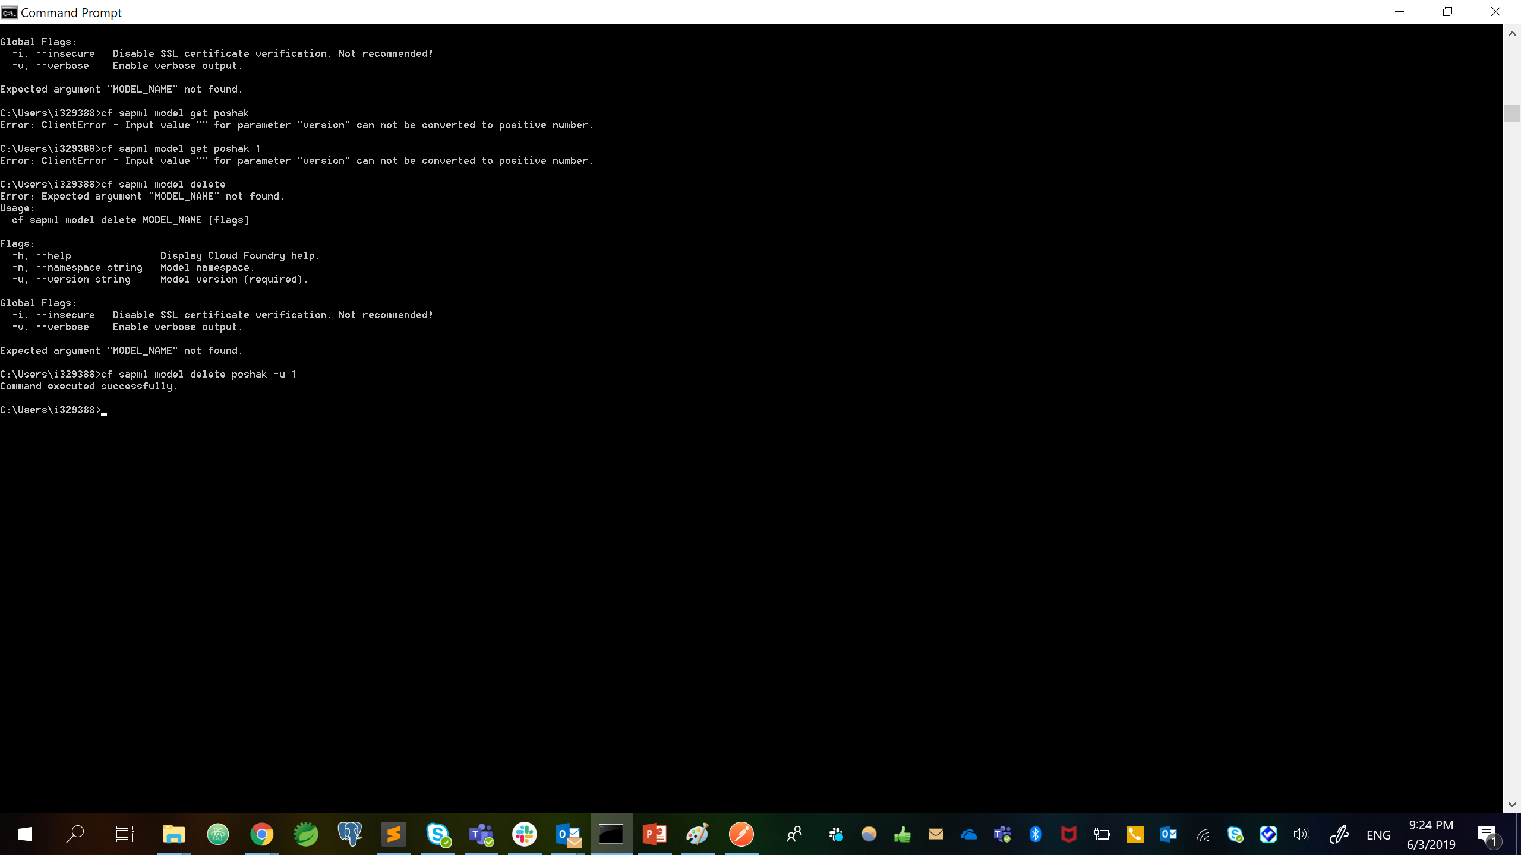

Step 6: - create the inference app to make an RPC call to Leonardo TensorFlow serving

Step7: - deploy the inference app to cloud foundry

Note: - go to the directory where your “manifest.yml” is present and issue command “cf push”

Note :- Refer the following repository for code reference <https://github.wdf.sap.corp/tech-know-school/Machine-Learning/tree/master/modules/6.%20SAP%20Leonardo/slides%20for%20bootcamp/byom>

Step 8: use postman to make a call to your inference app deployed on cloud foundry.

Step9: - in order to check the digit for its classification category you have to upload an image from the postman

Note:- Use this link for test data <https://github.wdf.sap.corp/tech-know-school/Machine-Learning/tree/master/modules/6.%20SAP%20Leonardo/slides%20for%20bootcamp/byom%20test%20data>

